# Cloud-Computing-Fundamentals:

## Cloud computing requirements:

1. **On-Demand Self-Service:** Provision and terminate using a UI/CLI without human interaction.
2. **Broad Network Access:** Access services over any networks on any devices using standard protocols and methods.
3. **Resource Pooling:** Economies of scale, cheaper service.
4. **Rapid Elasticity:** Scale up and down automatically in response to system load.
5. **Measured Service:** Usage is measured. Pay only for what you consume.

## Public vs Private vs Multi Cloud:

* **Public Cloud:** using 1 public cloud such as AWS, Azure, Google Cloud.
* **Private Cloud:** using **on-premises real cloud**. Example-AWS Outposts, Azure Stack & Google Anthros Must meet 5 requirements.
* **Multi-Cloud:** using more than 1 public cloud in one deployment. Example using AWS & Azure in a single deployment or using third party tools that provides some abstraction however not recommended.
* **Hybrid Cloud:** using public and private clouds in one environment
  + This is **NOT** using Public Cloud and Legacy on-premises hardware, this would be **Hybrid Environment**.

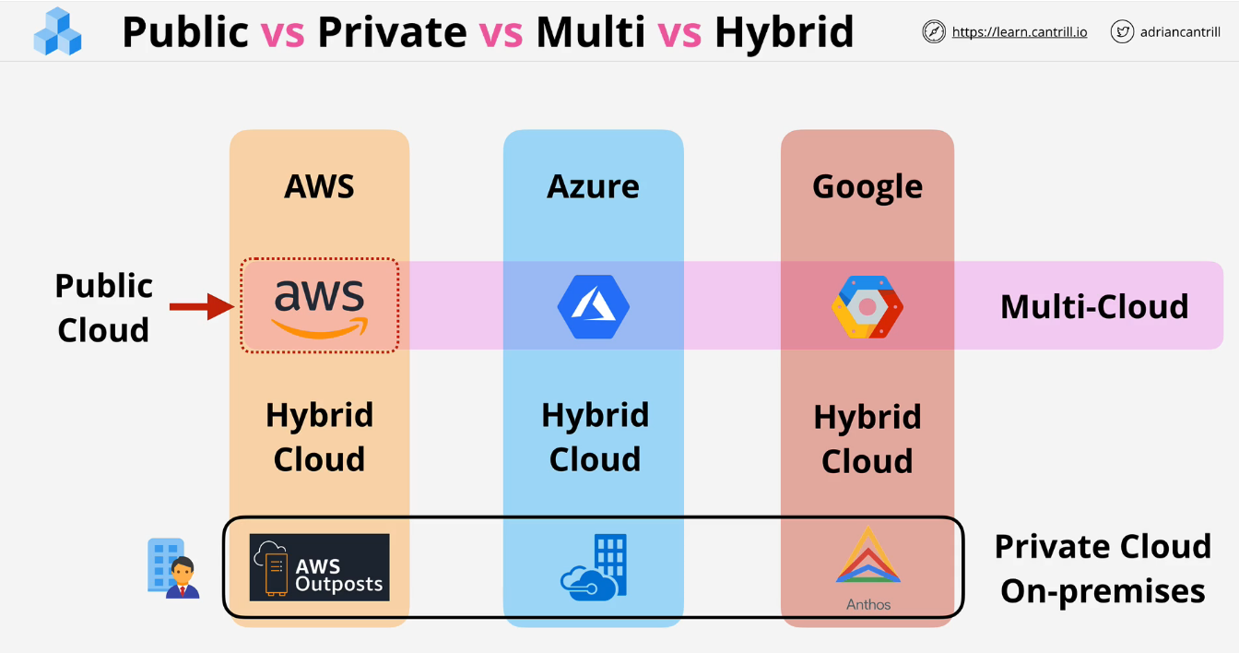

## Cloud Service Models:

The ***Infrastructure Stack* or *Application Stack*** contains multiple components that make up the total service. There are parts that **you** manage as well as portions the **vendor** manages. The portions the vendor manages and you are charged for is the **unit of consumption**

1. **On-Premises:** The individual manages all components from data to facilities. Provides the most flexibility, but also most IT intensive.
2. **Data Center Hosting:** Place equipment in a building managed by a vendor. You pay for the facilities only.
3. **Infrastructure as a Service (IaaS):** Vendor manages facilities and everything else related to servers up to the OS. You pay per second or minute for the OS used to the vendor. Lose some flexibility, but big risk reductions. **Example: AWS, Azure etc**
4. **Platform as a Service (PaaS):** Good for running an application only. The unit of consumption is the runtime environment. You manage the application and the data, but the vendor manages all else. Mainly used by developers. Example: **Heroku**
5. 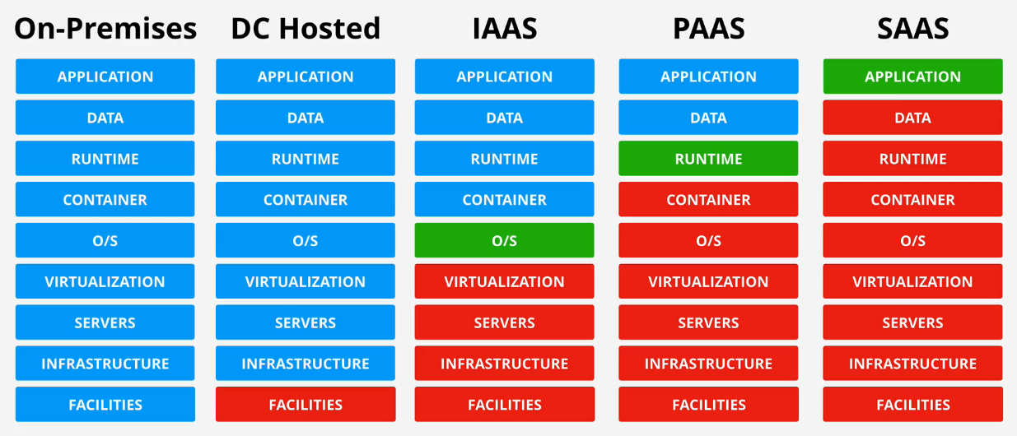**Software as a Service (SaaS):** You consume the software as a service. This can be Outlook or Netflix. There are almost no risks or additional costs, but very little control. Mostly used by Business. Example-Netflix, Dropbox, Gmail etc.

There are additional services such as ***Function as a Service*, *Container as a Service*, and *Database as a Service*** which be explained later.